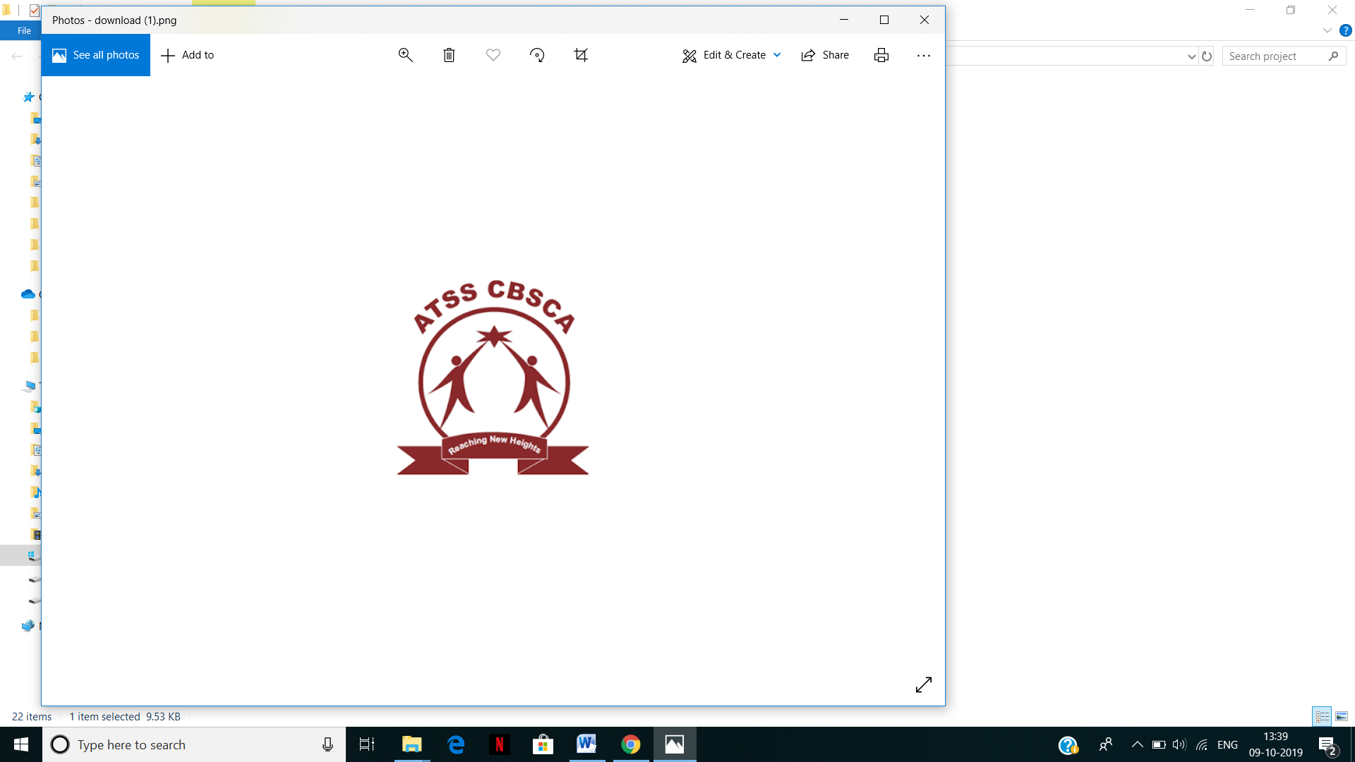

**ATSS College Of Business Studies &**

**Computer Application**

Chinchwad, Pune, Maharashtra, India-19

Academic Year :- 2019-20

**Project Title:-**

***“Online Cloth Shopping System***

***(Poshakh.com)”***

**Team Member’s :-**

**1.Shripad Joshi**

**2.Yash Gour**

**Project Guide:-**

**Prof.Swati Jamble.**

**Acknowledgement**

The Fulfillment and jubilation the accompany the successful completion of any task would be but incomplete without mention of people who made it possible, whose constant guidance and encouragement crowned the efforts with success.

First the foremost we thought to pay our due regards to this renowned institution, which provided us a platform and an opportunity to display our skills through the medium of project work.

We express our deep gratitude to our guide Prof. Swati Jamble who in their busy schedule provided us with support, encouragement, constructive, criticism & co-operation throughout the progress and the completion of the project “Online Cloth Shopping System”.

We are indebted to Prof .Dr. ArunaDeoskar Principal, ATSS College of Business Studies & Computer Application, for her sincere co-operation extended to us and for providing the support and encouragement.

Last but not the least we would like to thank our parents and friends for their encouragement given to make this project reality.

**Index**

|  |  |  |
| --- | --- | --- |
| **SR.NO** | **Particulars** | **Page.No** |
| 1. | **INTRODUCTION** | 4 |
| 1.1 | Introduction To System | 4 |
| 1.2 | Scope of System | 5 |
| 1.3 | Proposed Of System | 5 |
| 2. | **Analysis** | 6 |
| 2.1 | Fact Finding Techniques | 6 |
| 2.2 | Feasibility Study | 7 |
| 2.3 | H/w and S/w Requirements | 8 |
| 3. | **System Design** | 9 |
| 3.1 | Class Diagram | 9 |
| 3.2 | Use Case Diagram | 10 |
| 3.3 | Activity Diagram | 11 |
| 3.4 | Sequence Diagram | 12 |
| 3.5 | Data Dictionary | 13 |
| 4 | **System Design** | 16 |
| 5 | **Reports** | 20 |
| 6 | **Advantages And Limitation** | 22 |
| 7 | **Future Enhancements** | 23 |
| 8 | **Bibliography** | 24 |

**1 .Introduction**

**1.1 Introduction**

This project Online Cloth Shopping System(Poshakh.com) is developed on PHP and MySQL database.

The project Online Cloth Shopping System(Poshakh.com) is an online fashion store which will allow formal and informal merchants in developing and advertise and sell their product on internet. This would permit rural communities to make their wares available to rest of the world via world wide web. The objective of product is to create an e-commerce web portal with content management system which would allow product information securely.

The web portal will have online interface in the form of e-commerce website which allow users to buy goods from merchants

We developed this system with fully computerized method to manage all the data at present all the records are maintained manually. We have used PHP for business logic, MySQL as database, HTML for structure designing, CSS for web page formatting, Javascript for form animation.

This system is easy to understand and easy to interface of system user. It provides user ID and password which is used for data security. By the cause of user ID and password system is used by only the authorized person.

**1.2 Scope Of System**

* Every System has its well defined boundary. Everything inside the boundary constitutes the system. components and all that is outside their boundaries are called the environment.
* System boundary defines the scope of the system, which are other words also defines the system limitations.
* Admin can login and interact with database.
* Interactive approach enables the user to view Taxes on the screen.
* System Provides interactive object to view product details on the screen.
* Personal Id provided, so it maintain security and confidentially.
* It prevents Duplication of work.
* Reduce manual work.
* User friendly.
* User can search record easily.

**1.3 Proposed Of System**

This Project Deals With the Online Cloth Shopping System:-

* Provides the selling goods over the internet.
* Also manages the advertise and sell their goods with details.
* Manages the information of various fashions.
* To increase efficiency of managing products details.
* It deals with monitoring information and transactions of payment .
* Manage the information of customers.
* Integration of various types of clothes style.
* View and add records of products.

**2.Analysis**

**2.1 Fact Finding techniques**

To first activity in analysis phase is to do the preliminary investigation data collecting is very important for this we can use fact finding techniques.

* **Interview:-**

We use this technique frequently to collect information about existing systems from the potential user. We choose some people from our surrounding who were either user in some activity related with our project. These help us to understand all stages involve in activity.

* **Record review:-**

This is the most beneficial technique for us while developing my database. We studied existing system, file structures which is used by government and we made our system more user friendly.

* **Observation:-**

While finding the facts we keenly observed all the activities of existing system. We paid attention to the usage of file and documentation, record keeping and the handling of queries in the existing system. Observation helped us in finding out the functioning apart from the ideal or desire.

* **Questionnaire:-**

We used this technique in the initial phase of our project. We conducted this session by asking questions to our friends who recently applied for license. Also we visit to the RTO office to collect some new information by asking some questions.

**2.2 Feasibility Study**

A feasibility study is conducted to select the best system that meets performance requirements. This entails an identification description, an evaluation of candidate system, and the selection of the best system for the job.

A statement of constraints, the identification of specific system objectives and a description of outputs define a system’s required performance. The analyst is then ready to evaluate the feasibility of candidate system to produce these outputs.

1. **Technical feasibility** :- The technical feasibility assessment is focused on gaining an understanding of the present technical resources of the organization and their application to the expected needs of the proposed system. It is an evaluation of the hardware and software and how it meets the needs of the proposed system
2. **Economic feasibility :-** The purposed of the economic feasibility assessment is to determine the positive economic benefits to the organization that the proposed system will provide. It includes quantification and identification of all the benefits expected. This assessment typically involves a cost/benefits analysis
3. **Operation feasibility :**- Operational feasibility is a measure of how well a proposed system solves the problems. The problems, and takes advantage of the opportunities identified during scope definition and how it satisfies the requirements identified in the requirements analysis phase of system development.

The operational feasibility assessment focuses on the degree to which the proposed development projects fits in with the existing business environment and objectives with regard to development schedule, delivery date, corporate culture, and existing business processes.

1. **Legal feasibility :-** Determines whether the proposed system conflicts with legal requirements e.g. a data processing system must comply with the local data protection acts.

**2.3 Hardware & Software Specifications**

**Software Configuration:-**

Operating Platform :- WINDOWS 2000/XP/10

Database :- MySQL

Technology :- PHP

**Hardware Configuration:-**

RAM :- Min 1GB

Hard Disk :- Min 10GB

Processor :- Pentium Processor.

**3. System Design**

**3.1 Class Diagram**

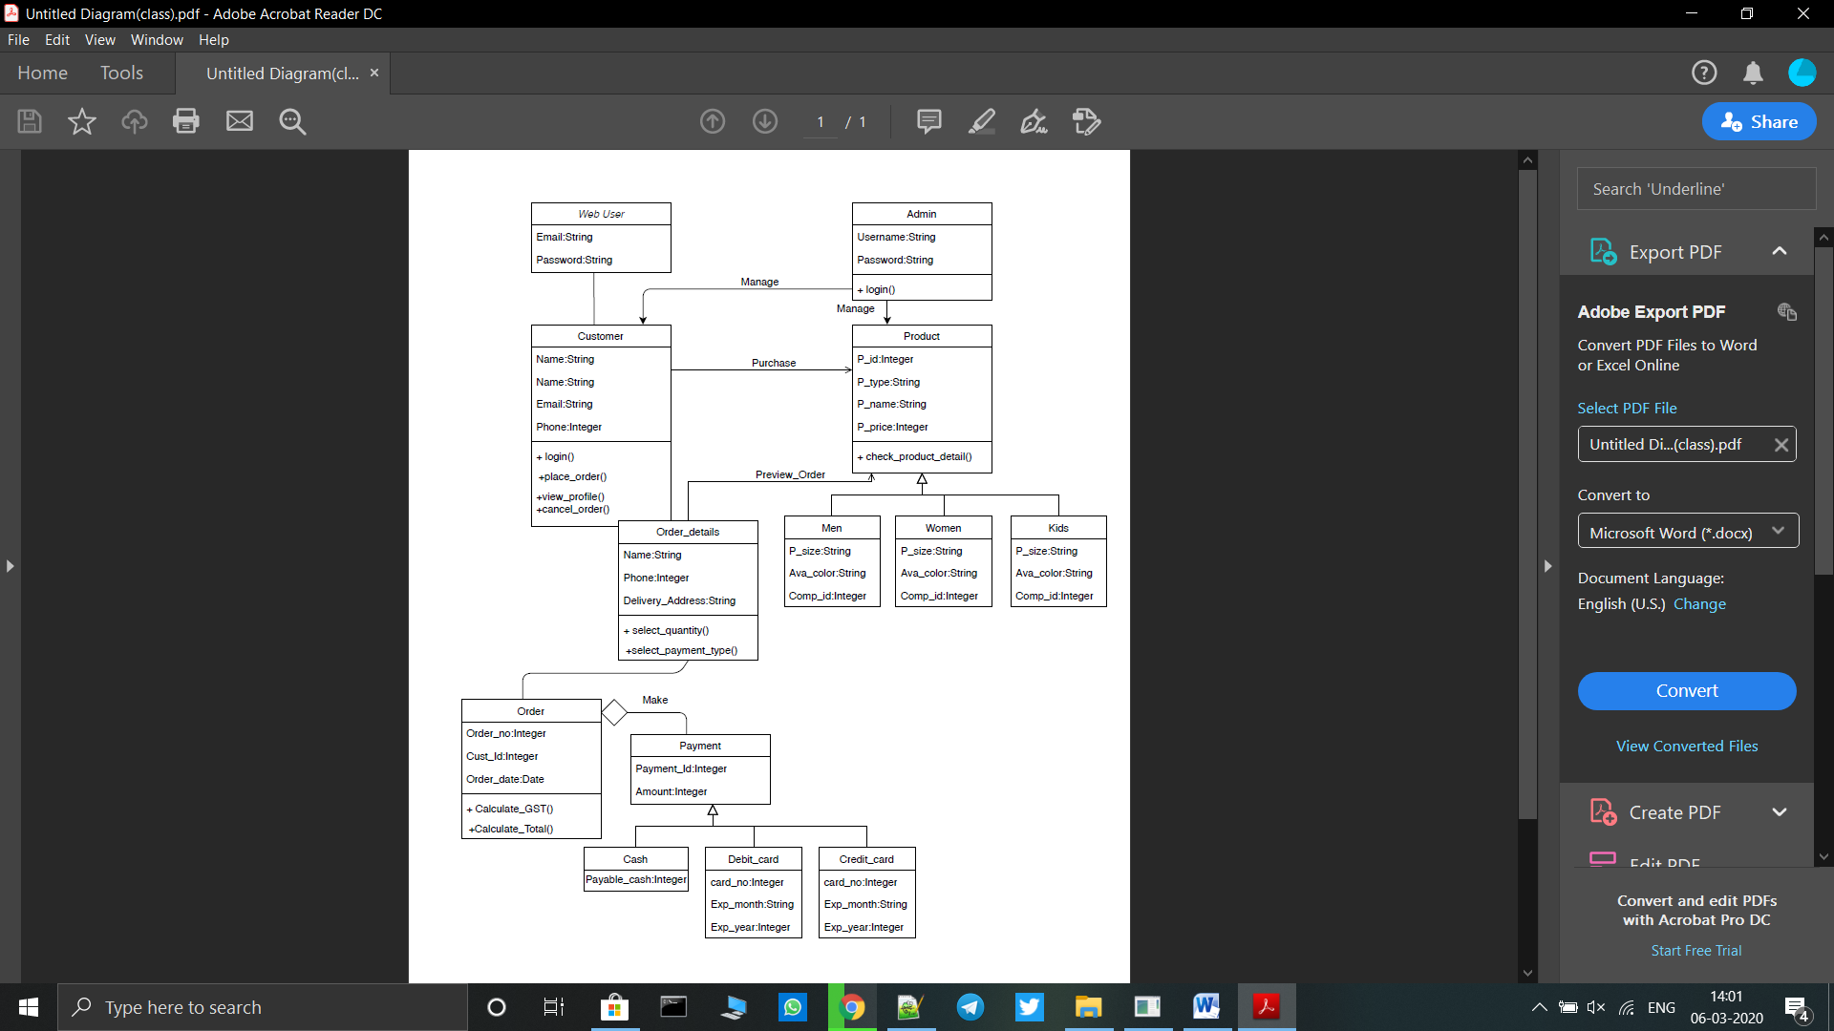

**3.2 Use Case Diagram**

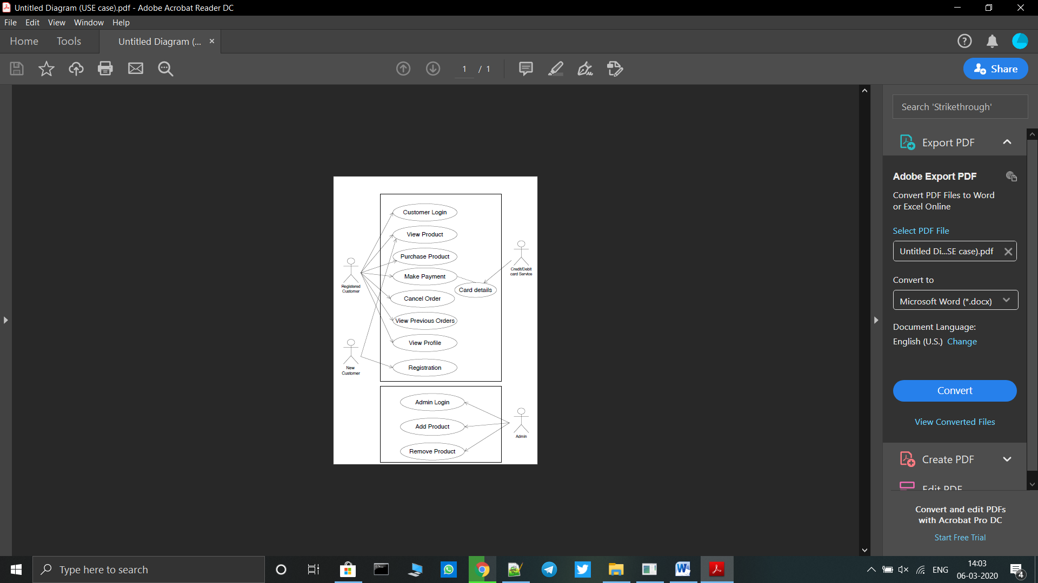

**3.3 Activity Diagram**

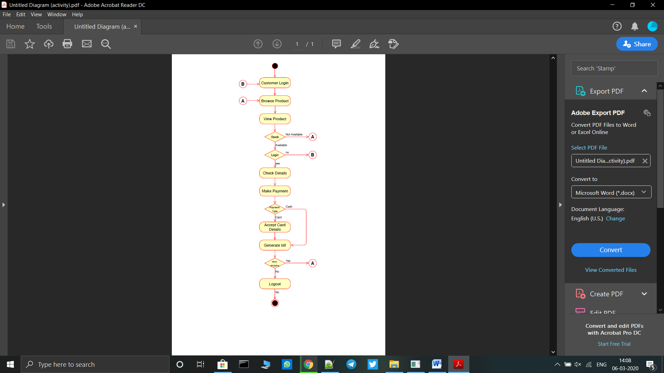

**3.2 Sequence Diagram**

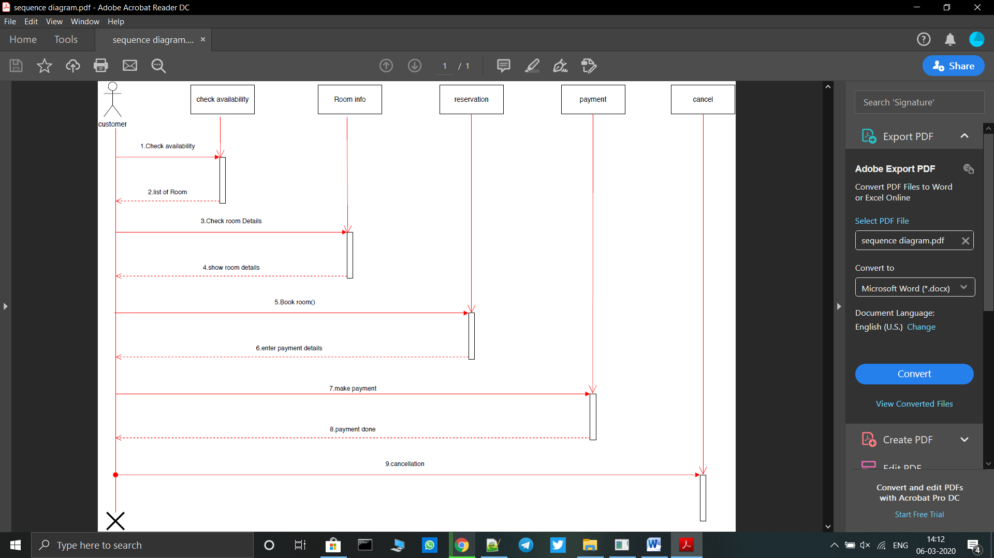

**3.4 Data Dictionary**

**Admin Login**

|  |  |  |
| --- | --- | --- |
| **Field_name** | **Datatype** | **Description** |
| User name | Varchar | Store’s admin username |
| Password | Varchar | Store’s admin Password |

**Customer Registration**

|  |  |  |
| --- | --- | --- |
| **Field_name** | **Datatype** | **Description** |
| cust_id | Int | Store’s the customer’s id |
| cust_name | Varchar | Store’s the customer’s name |
| cust_email | Varchar | Store’s customer’s email |
| Mobile_no | Int | Store’s customer’s mobileno |
| Password | Varchar | Store’s customer’s password |
| Gender | Varchar | Store’s customer’s gender |
| Addr | Varchar | Store’s customer’s address |

**Bill Info**

|  |  |  |
| --- | --- | --- |
| **Field_name** | **Datatype** | **Description** |
| bill_id | int | Store’s the customer’s billid |
| Cust_id | Int | Store’s the customer ’s id |
| bill_address | varchar | Store’s customer’s address |
| Shi_address | Varchar | Store’s customer’s address |
| O_date | Date | Store’s customer’s o_date |
| I_date | Date | Store’s customer’s date |
| P_id | Int | Store’s product’s id |
| Quantity | Int | Store’s customer’s quantity |
| GST | Int | Store’s customer’s GST |
| Total | Int | Store’s customer’s total |
| Grand total | Int | Store’s customer’s G total |

**Company Info**

|  |  |  |
| --- | --- | --- |
| **Field_name** | **Datatype** | **Description** |
| c_id | Int | Store’s the company’s id |
| c_name | Varchar | Store’sthe company ’s name |
| City | Varchar | Store’s the company’scity |
| state | Varchar | Store’s the company’sstate |

**M_top**

|  |  |  |
| --- | --- | --- |
| **Field_name** | **Datatype** | **Description** |
| p_id | Int | Store’s the product’s id |
| p_name | Varchar | Store’s the product’s name |
| c_id | Int | Store’s the product’s id |
| p_price | Int | Store’sthe product ’s price |
| P_type | Varchar | Store’s the product’stype |
| Ava_size | Varchar | Store’s the product’size |
| i_name | Varchar | Store’sthe product’s i_name |
| Ava_color | Varchar | Store’s the product’scolours |
| Rel_date | timestamp | Store’s the product’s date |
| Stock | int | Store’s the product’sstock |

**W_top**

|  |  |  |
| --- | --- | --- |
| **Field_name** | **Datatype** | **Description** |
| p_id | Int | Store’s the product’s id |
| p_name | Varchar | Store’s the product’s name |
| c_id | Int | Store’s the product’s id |
| p_price | Int | Store’sthe product ’s price |
| P_type | Varchar | Store’s the product’stype |
| Ava_size | Varchar | Store’s the product’size |
| i_name | Varchar | Store’sthe product’s i_name |
| Ava_color | Varchar | Store’s the product’scolours |
| Rel_date | timestamp | Store’s the product’s date |
| Stock | int | Store’s the product’sstock |

**Kids_Info**

|  |  |  |
| --- | --- | --- |
| **Field_name** | **Datatype** | **Description** |
| p_id | Int | Store’s the product’s id |
| p_name | Varchar | Store’s the product’s name |
| c_id | Int | Store’s the product’s id |
| p_price | Int | Store’sthe product ’s price |
| P_type | Varchar | Store’s the product’stype |
| Ava_size | Varchar | Store’s the product’size |
| i_name | Varchar | Store’sthe product’s i_name |
| Ava_color | Varchar | Store’s the product’scolours |
| Rel_date | timestamp | Store’s the product’s date |
| Stock | int | Store’s the product’sstock |

1. **System Design**

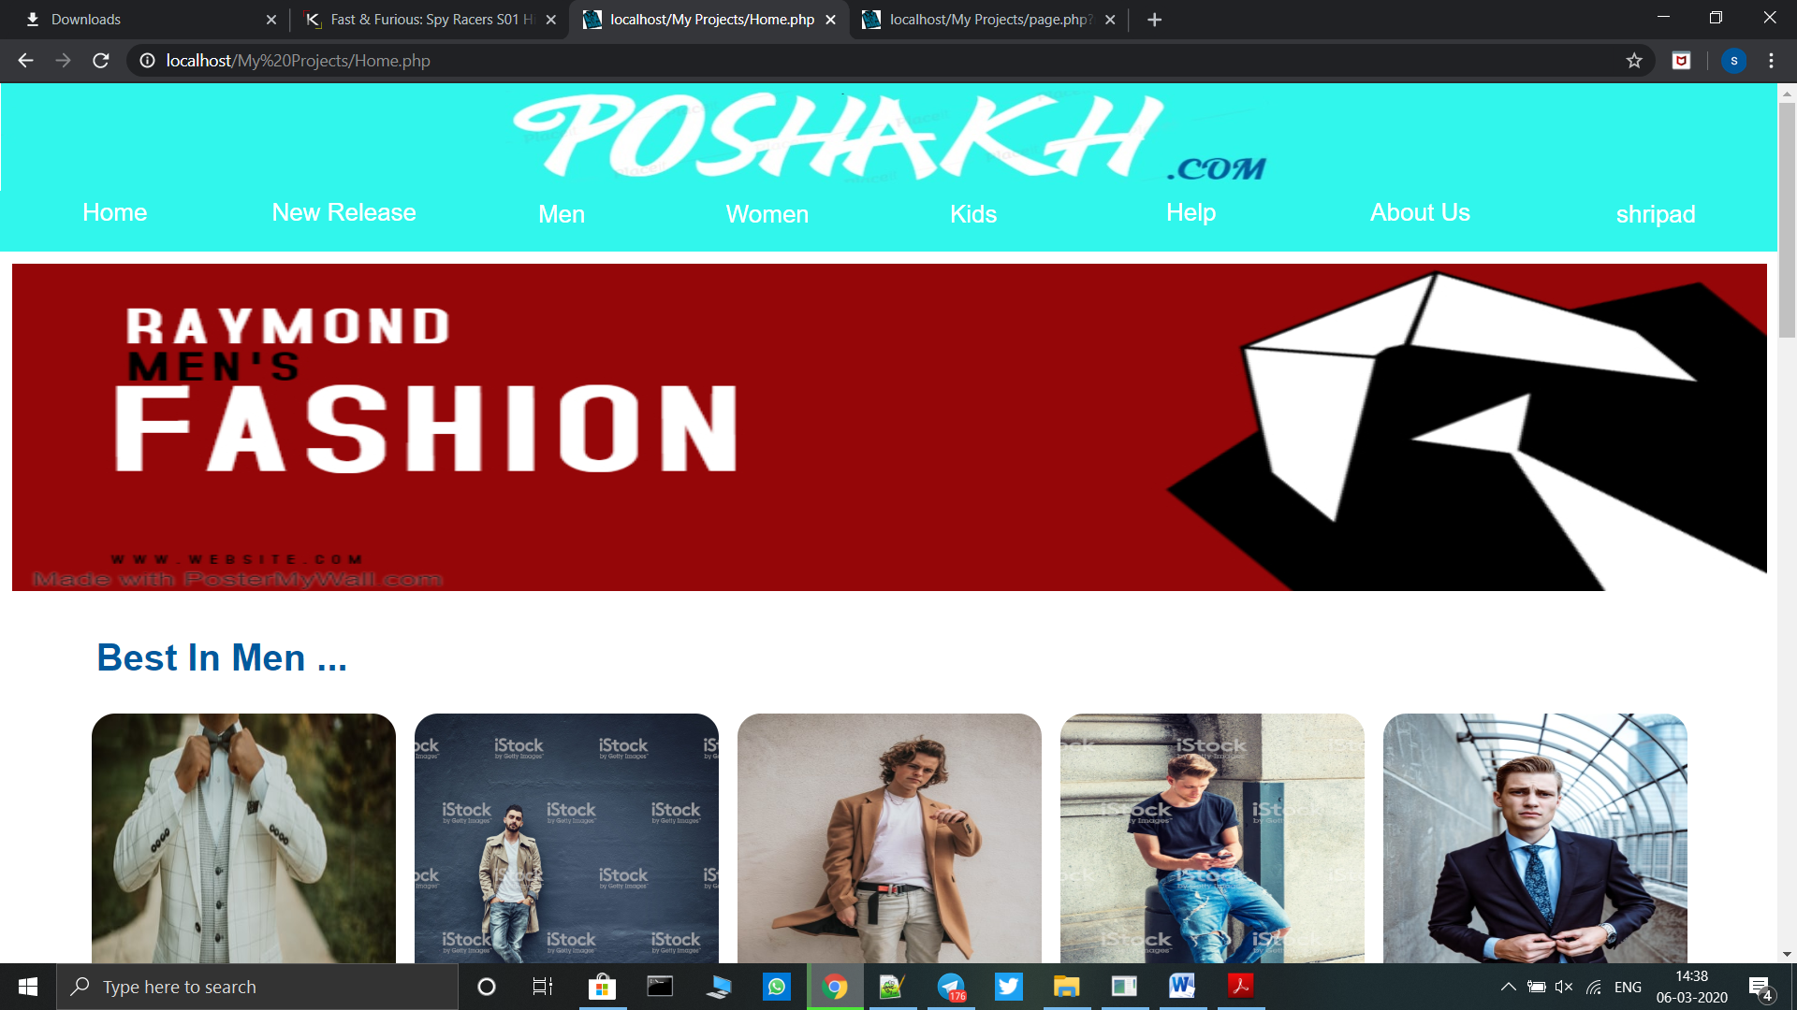

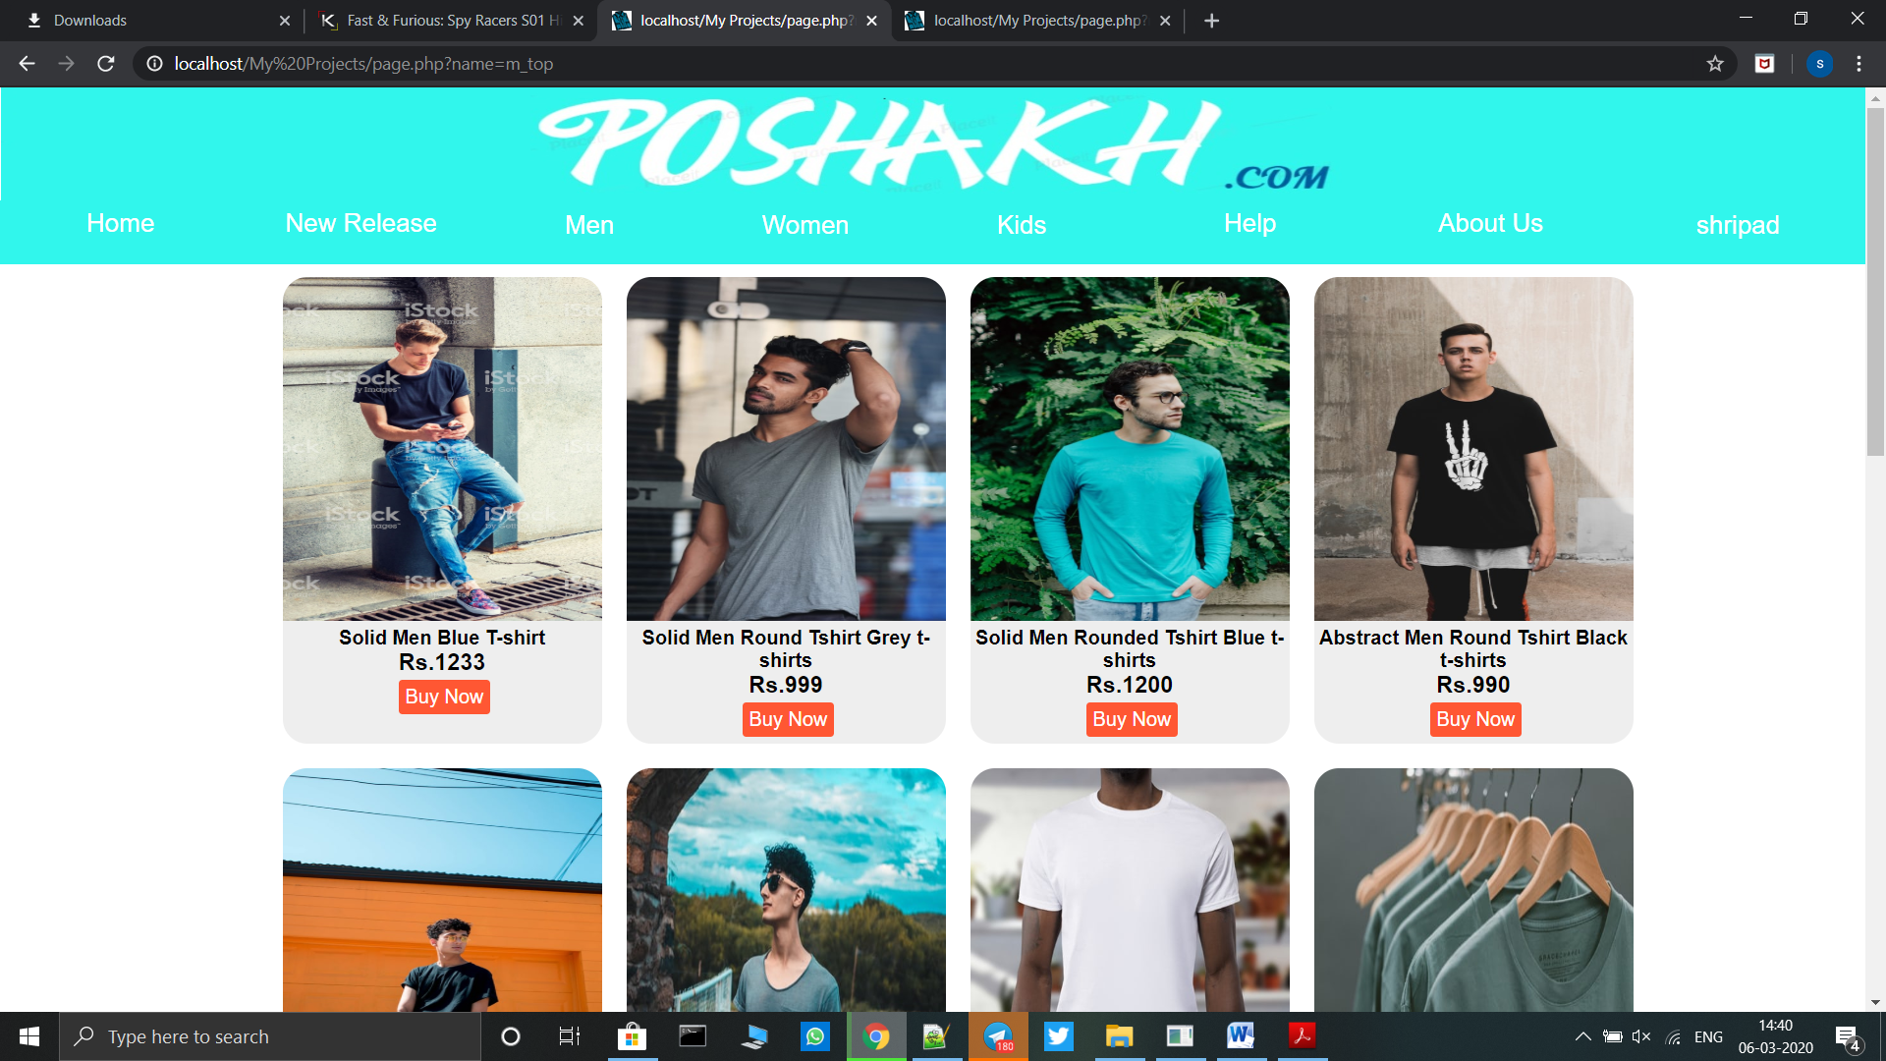

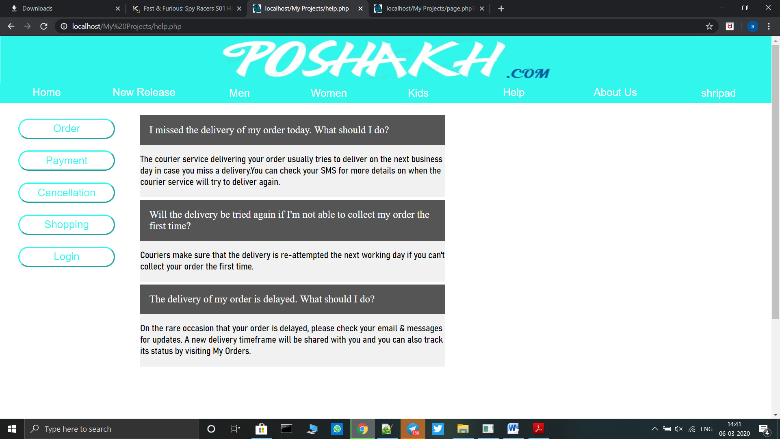

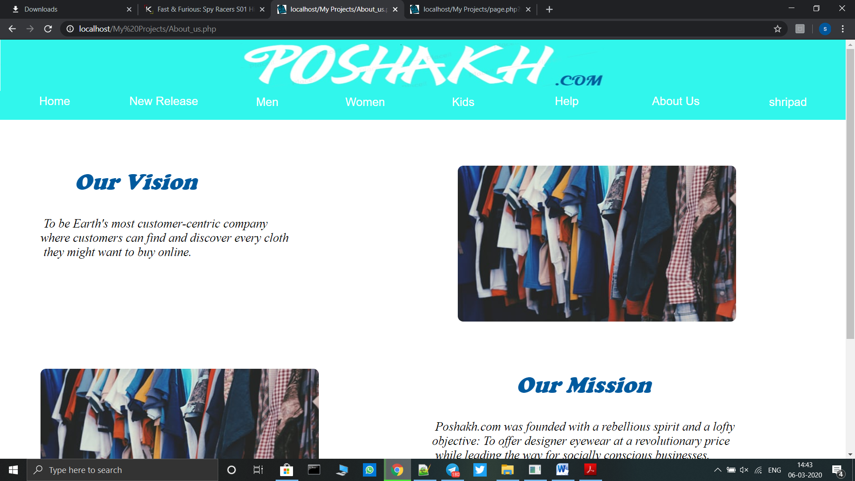

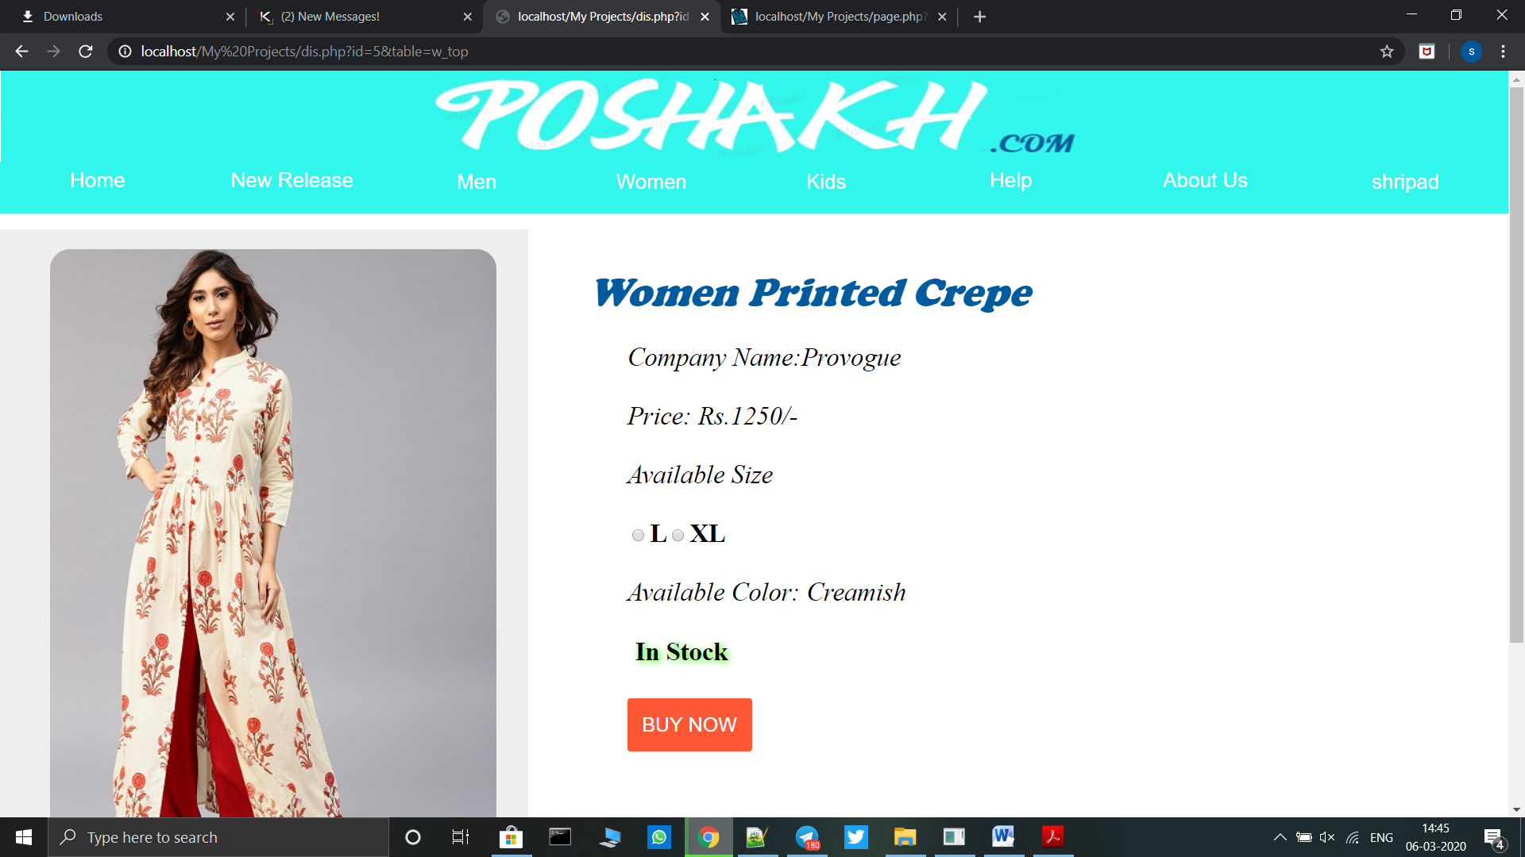

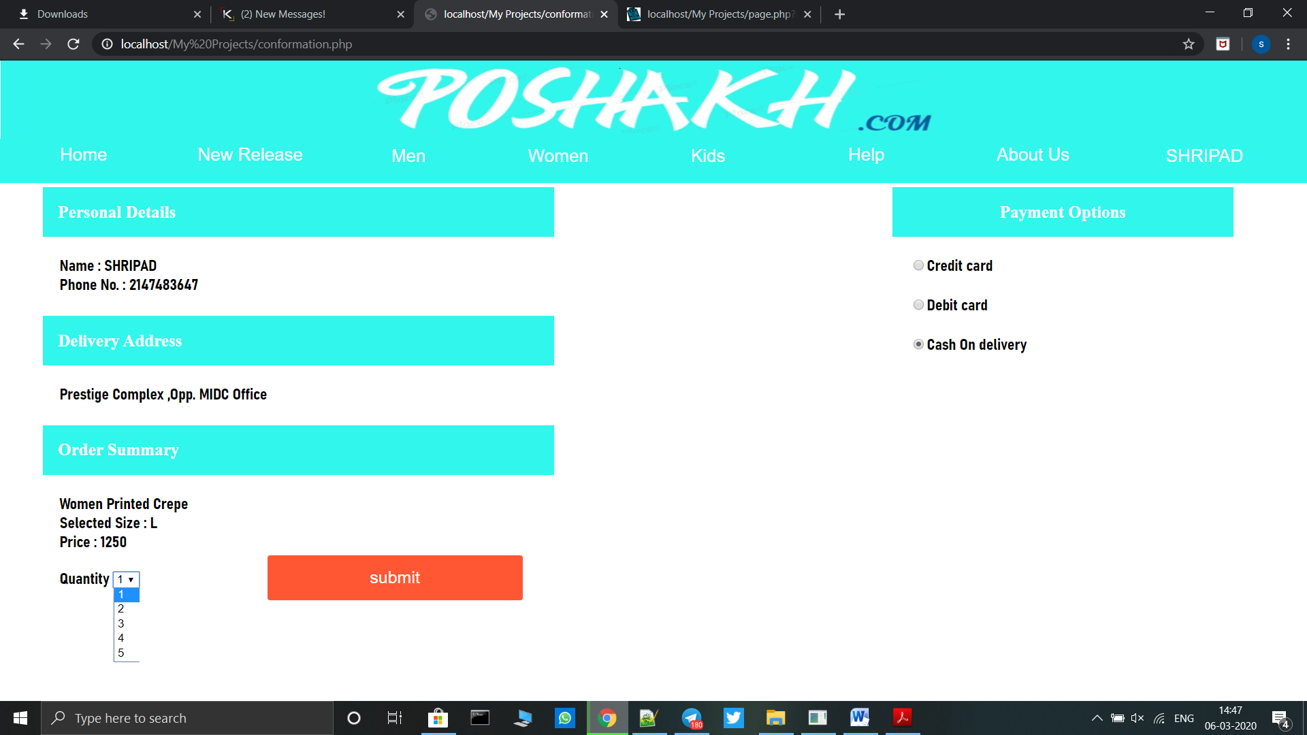

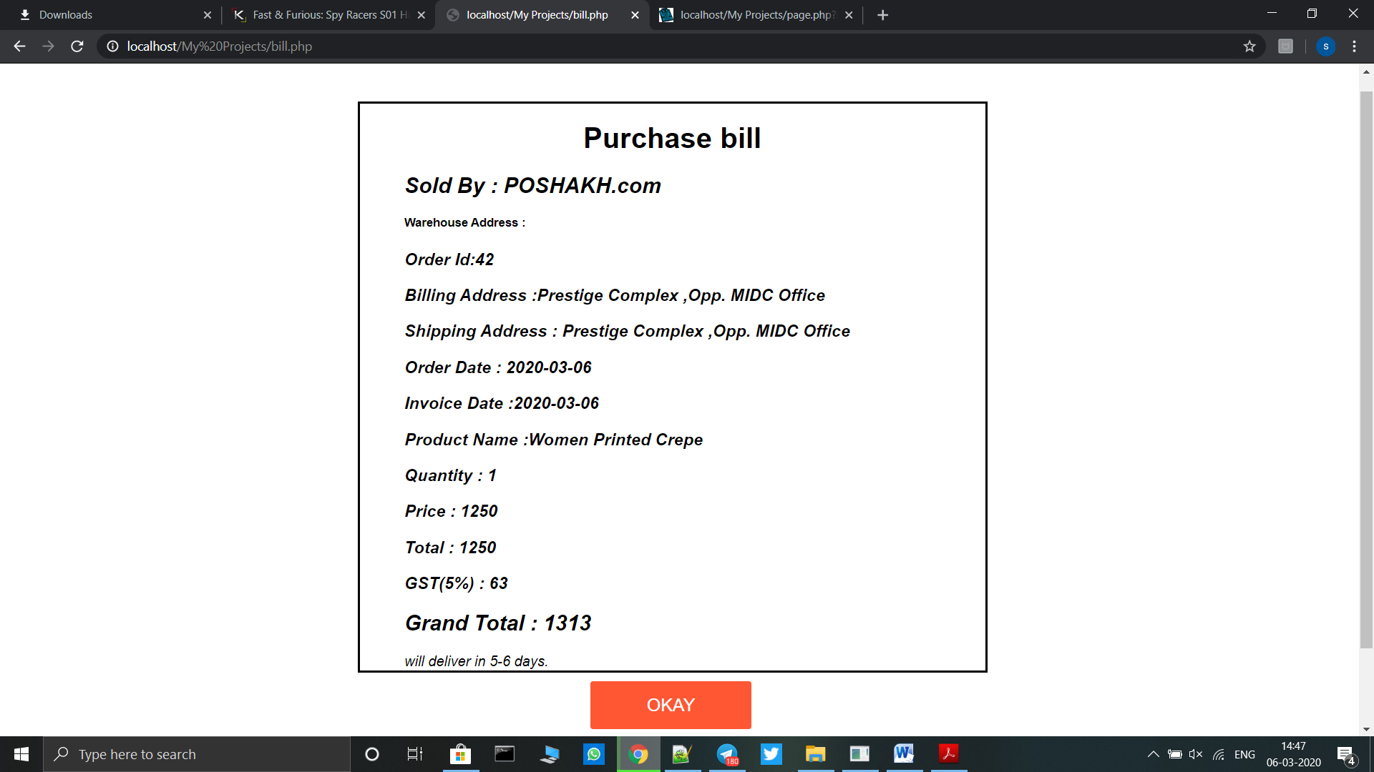

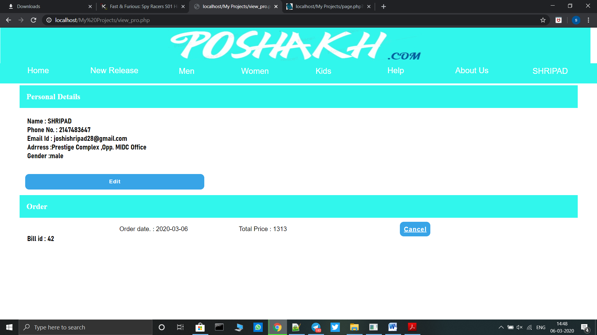

**5.Report**

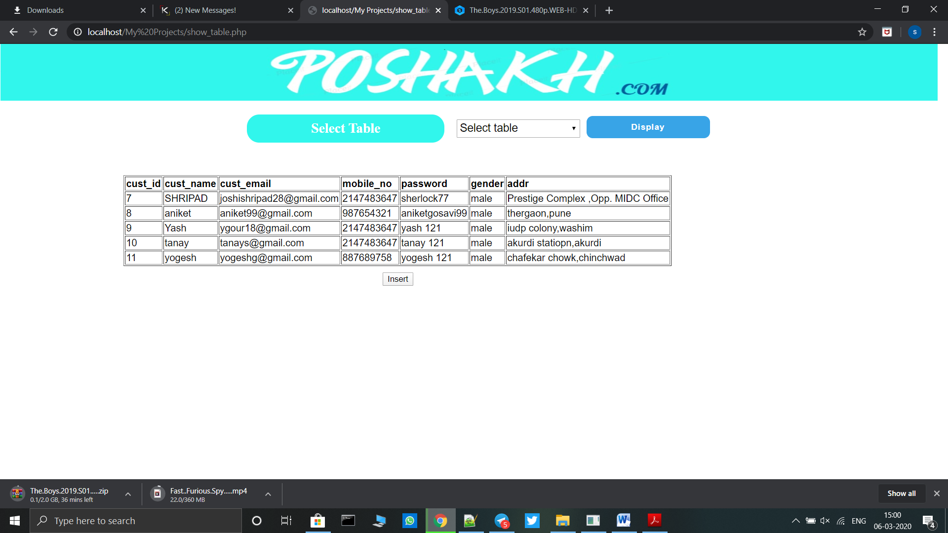

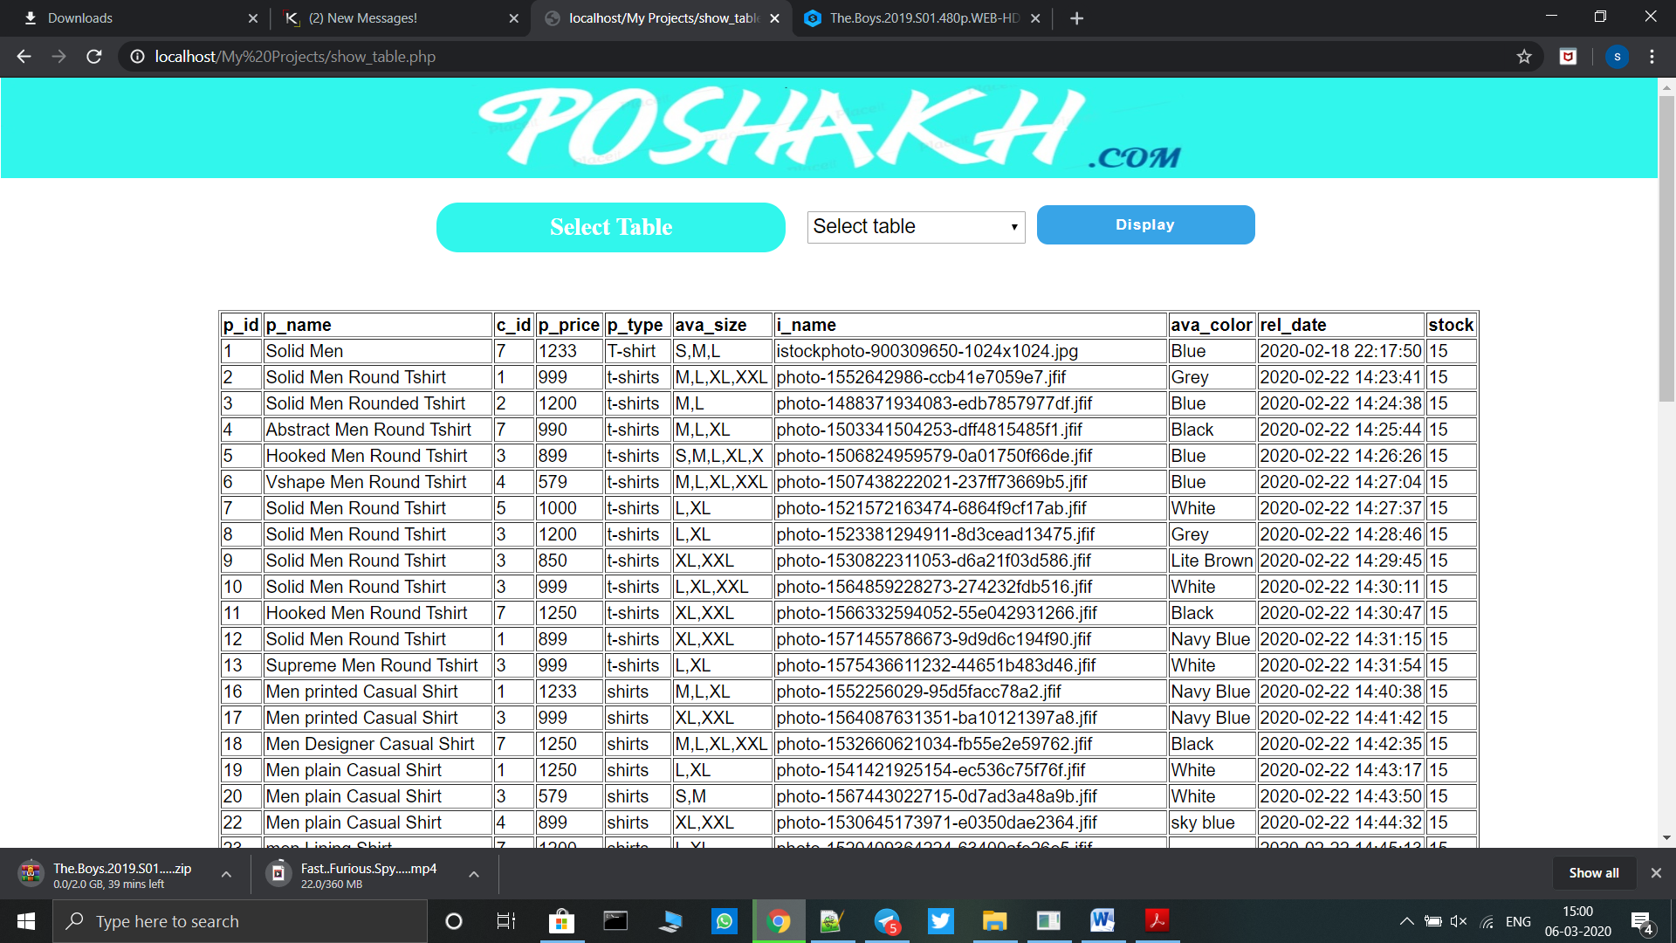

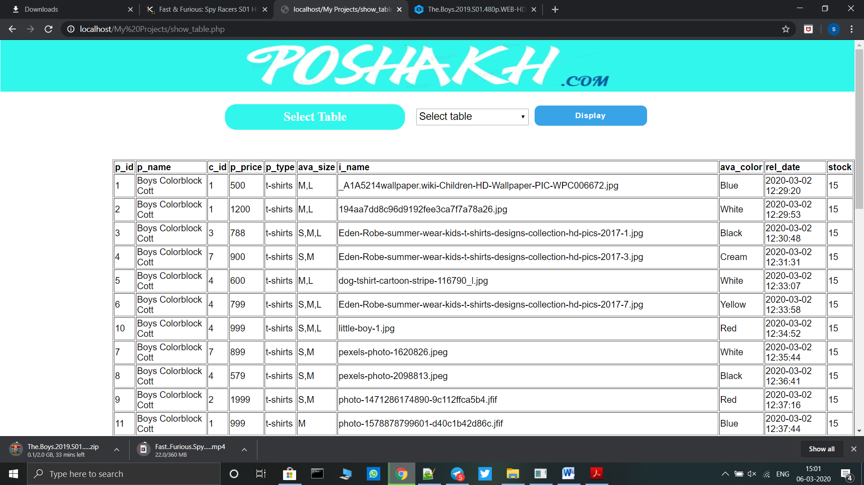

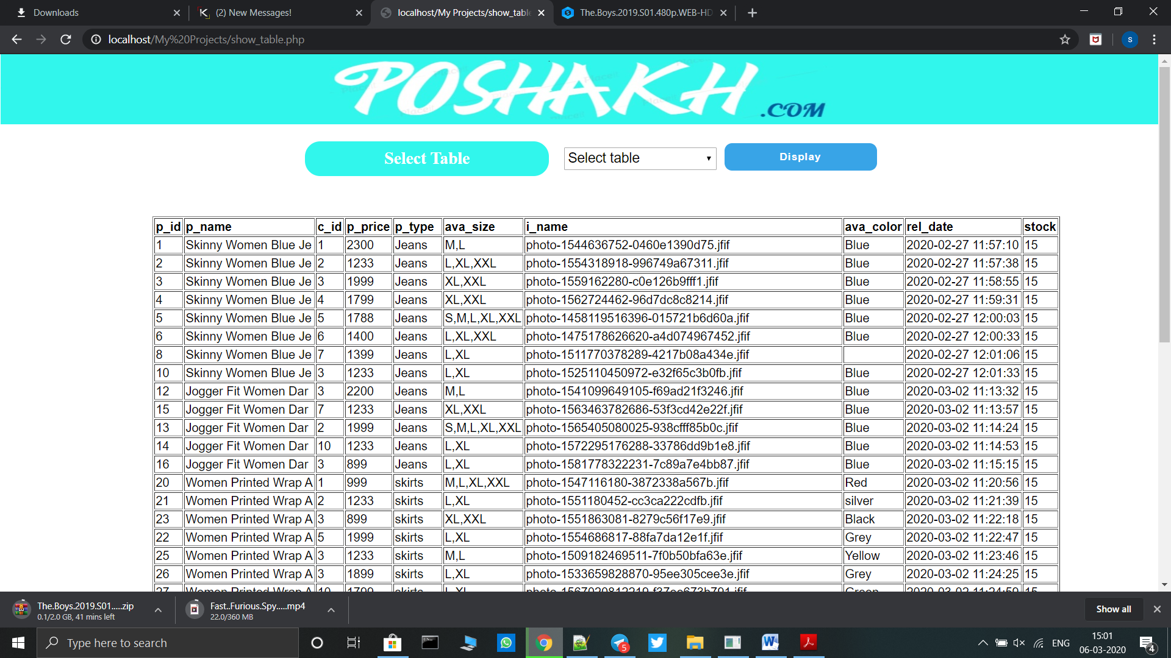**6. Advantages & Limitation**

**6.1 Advantages:-**

* Has a clearly arranges and users friendly interface
* Easy to use and minimum data entry
* Security of the data
* Access to authorized person only
* Proper entry of the data
* 24/7 Availability
* Provides difference types of payment options

**6.2 Limitations:-**

* It supports only one language.
* A few Constraints are not included such as Replacement, payments using UPI.
* Technology needs to be ruled by humans. The technology should not rule the man. The systems cannot replace the human tasks and duties which definitely require the office structure.
* The Failure of system depends on hardware life, its quality and presence of Bugs in the system.
* There is always need to remember the ID and password in order to perform any kind of operations in system.

**7. Future Enhancement**

In this system till now we make all the possible things which are very helpful as well as easily understandable to our websites user. We develop this system for to make and give medium for user just this thing we take in our mind and we develop this system.

But we all know one thing is that in IT sector everyday something new development is happening that’s why in our System we also want to make enhancement for future. We can enhance our project as follows:

* We will try to make our system more user – friendly than now.
* We can try to develop this system in different languages as per countries.
* We will try to provides, statistical report for admin.
* We will add some more functionality in future.
* We will also try to add Data Integrity options.
* We will try to add more payment options like UPI.
* We will try to add product replacement facility.

**8.Bibliography**

**8.1 Referred Books:-**

1. The Complete Reference SQL

Author: Steven Holzner

1. PHP(Tech media)

Author: Greg Perry

1. The complete reference HTML

Author: Evangelos Petroutsos

**8.2 Websites:-**

* [**WWW.Wikipedia.Com**](http://WWW.Wikipedia.Com)
* [**WWW.W3school.Com**](http://WWW.W3school.Com)
* **WWW.stackoverflow.Com**